Introduction to In-context Learning
In-context learning is a specific method of prompt engineering where demonstrations ​of the task are provided to the model as a part of the prompt in natural language. ​However, in-context learning doesn’t require additional training. ​A new task is learned from a small set of examples presented within the context or ​prompt at inference time.
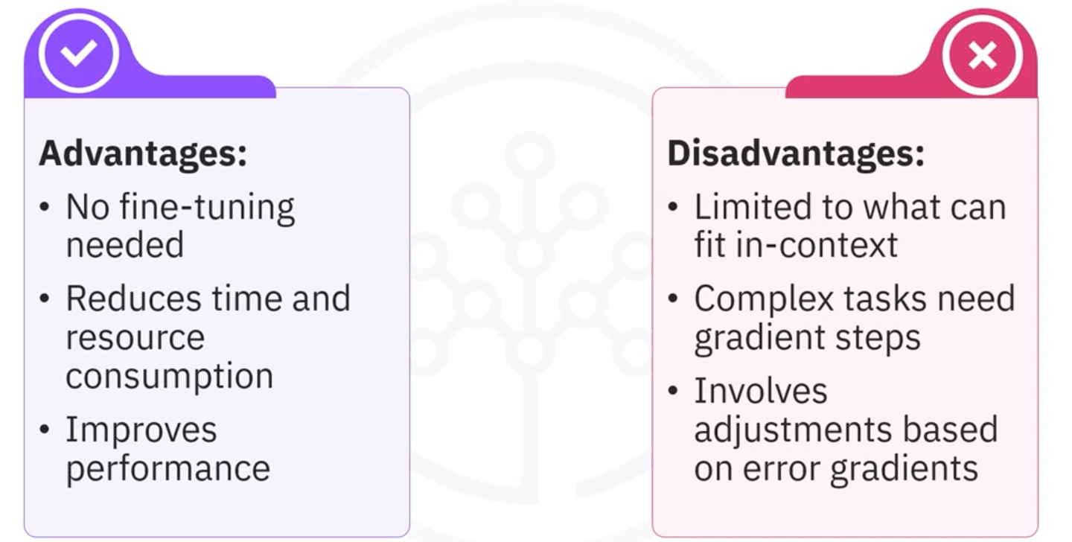

What are prompts? ​Essentially, prompts are instructions or inputs given to an LLM designed to ​guide it toward performing a specific task or generating a desired output. There are two main components to a prompt. ​(Instructions and Context) Instructions are clear, direct commands that tell the AI what to do. ​They need to be specific to ensure the LLM understands the task. Context includes the necessary information or ​background that helps the LLM make sense of the instruction. ​It can be data, parameters, ​or any relevant details that shape the AI's response.

A prompt consists of four key elements: instructions, context, input data, ​and output indicator.

